Contributors: Chittaranjan Yajnik, and Shilpa Joshi

24. Diabetes - overview and nutritional management

Key messages
- Diabetes is a metabolic disorder in which blood glucose is raised, and which can cause serious complications and reduce immunity.
- Diabetes type 2 and gestational diabetes are increasing rapidly in developing countries where information and facilities for managing them are scarce.
- Early detection of diabetes is key to preventing its complications.
- Nutrition counselling is essential to managing diabetes.
- Diabetic patients can eat the same healthy foods as everyone else but in the right quantities.

24.1 What is diabetes?
Diabetes is a metabolic disorder in which blood glucose is raised and which is associated with serious vascular complications. This chapter covers type 2 and gestational diabetes because they are preventable (type 1 diabetes is not).

How diabetes develops
Glucose is the main source of energy of the body and is released as we digest food. The pancreatic hormone, insulin, helps glucose to enter into the cells, where it is metabolized to produce energy.
In diabetes the pancreas produces insufficient insulin or available insulin is not able to act on the cells (insulin resistance). So glucose accumulates in the blood causing high blood sugar (hyperglycemia) and some might spill into the urine causing diabetic symptoms – see below. However many people with diabetes either have no symptoms, or mild symptoms, and do not seek medical help. They remain undiagnosed, allowing the diabetes to progress causing complications. In pregnancy, various hormones increase insulin resistance and in some women glucose level rises to diabetic levels; this is called gestational diabetes.

Who gets diabetes?
Diabetes used to be thought of as a disease of the rich, but it is now occurring at an alarming rate among the poor. Most diabetic patients live in developing countries, where the prevalence is often higher than in developed countries.
Risk factors for type 2 diabetes are:
- Non-modifiable:
- family history of diabetes;
- age above 40 years; and
- member of high risk population: for example, from South Asia, South/Central America, and rapidly developing African countries, and migrants.
- Modifiable:
- obesity, especially abdominal obesity; and
- sedentary life style;

Section 23.3 explains the ‘nutrition transition’ which is leading to the ‘double burden’ of an existing high prevalence of undernutrition, and a rapidly rising prevalence of the non-communicable diseases (NCDs).
Box 24.1 describes diabetes in developing countries using India as an example.
Box 24.1. Diabetes in India
The prevalence of diabetes among Indians, inside and outside India is very high. Indians get diabetes at least 10 years younger than white populations, and at a lower body mass index. There is a high prevalence of Impaired Glucose Tolerance at a young age and a rapid progression to diabetes. The epidemic now affects poor and rural populations, who know little about diabetes and cannot afford health care. There is also a lack of awareness and action by health workers. As a result, a large proportion of diabetic patients remain undiagnosed (an estimated 50% of urban and 70% of rural diabetic patients). India is the world’s capital of low birth weight babies, due to the cycle of maternal undernutrition over several generations. Poor foetal growth is a risk factor for future diabetes, and cardiovascular disease – see Section 23.3. Indian babies look thin but actually their bodies have more fat than white babies suggesting that the predisposition to diabetes starts in the womb.
End box

Dangers of diabetes
Uncontrolled diabetes causes serious complications: blindness, kidney failure and gangrene (of fingers, toes and lower limbs). It reduces immunity thus making infections like tuberculosis more common.
In Africa acute metabolic complications are a major cause of diabetic deaths. Hypertension and blood lipid abnormalities are often present in people with diabetes and increase the risk of cardiovascular complications.
Gestational diabetes increases the risk to:
- The mother of complications like urinary infection, and hypertension; and
- The baby of being born large-for-gestational age causing difficulties at the time of delivery, and of developing diabetes and obesity later.
Gestational diabetes usually disappears after pregnancy but mother and child are at increased risk of developing type 2 diabetes later.

Difficulties in management
The quality of diabetes care is especially poor in developing countries because:
- Most patients lack knowledge about diabetes and/or are poor, uninsured and unable to pay for treatment; and
- Health workers are poorly trained, especially in dietary counselling, and health systems lack diagnostic facilities and have inadequate supplies of medicines.
The situation will get worse as diabetes becomes more prevalent (as populations age) and occurs at a younger age (as obesity increases among children and young adults).

24.2 Management of diabetes and other obesity-related non-communicable diseases
Diabetes and other obesity-related diseases are incurable so prevention is key to control. The aims of prevention are to help at-risk people, by sympathetic counselling, to maintain a healthy weight, eat a nutritious diet, and take plenty of exercise.
Patient education in diet and food choice is essential to prevent, and manage, obesity, diabetes and other NCDs.
The lack of qualified nutritionists means doctors and nurses with little dietetic knowledge often give dietary counseling. They and their patients need simple dietary guidelines like those below.

Who to treat?
Most patients have no symptoms but anyone with abdominal obesity is likely to have hyperglycaemia. Sometimes hyperglycaemia causes frequent hunger, thirst, and urination.

Diabetes is diagnosed by measuring blood glucose. Diabetes is defined by:
- A fasting plasma glucose of 126 mg/dL (or 7.0 mmol/L) and higher (i.e. hyperglycaemia); and
- A random or post-meal plasma glucose level of 200 mg/dL or more (see International Diabetes Federation 2012 in Resources).
Refer anyone with hyperglycaemia, with or without symptoms, for treatment and dietary counseling.

Educational strategies for controlling diabetes and its complications
Most important in the treatment of type 2 diabetes and gestational diabetes are:
- Counselling patients on food choices and weight control so that blood glucose levels are kept within safe limits and the risk of complications is reduced; and
- Monitoring patients regularly for complications.

Make sure diabetic patients, and their carers understand:
- What diabetes is, its symptoms and potential dangers, and the aims of treatment;
- That, with good management and a healthy lifestyle, a full and active life is possible and complications are less likely to occur;
- That patients are largely responsible for controlling their own diabetes; and
- How to deal with hypoglycaemia (low blood sugar) or hyperglycaemia (high blood sugar).

Counsel patients, and their carers on:
- Weight control. Patients should aim to reach and keep a sustainable healthy weight, and lose weight if advised – Sections 15.6 and 15.7 gives cut-off levels for healthy weights for children (using weight-for-height) and for adolescents and adults (using Body Mass Index); Section 23.2 gives cut-off levels for waist measurements;
- What to eat and food preparation – see below. Guidelines for healthy eating are in Chapter 9 and for losing weight are in Box 24.2;
- Regular physical activity - at least 30 minutes of exercise that ‘makes you breathe faster’ each day.

Dietary guidelines for diabetics
Almost everyone newly diagnosed with diabetes asks, “Can I eat the same food as other people?” This is a valid question as preparing separate meals is time-consuming, and many people eat outside the home. In most places food labelling is poor. Reassure patients that they can eat the same healthy diet that is recommended for everyone, but they should have regular hours for meals and snacks especially if they are on insulin. So there is no need to eat special foods, but explain to them that it is easier to keep their blood sugar at the correct level if they:
- Spread the intake of starchy foods evenly throughout the day, and from day to day, and eat at regular intervals at the same time each day;
- Eat about three healthy meals including breakfast, and small healthy snacks in-between. Eating breakfast helps to control weight and glucose level - skipping it can lead to imbalanced eating later in the day;
- Avoid large snacks between meals;
- Correct a low blood sugar (if they have symptoms or a reading less than 70 mg/dL) with 15 g of simple carbohydrate such as 3 teaspoons of plain sugar, or a sweetened drink. They do not need a large snack;
- Snack at night if dinner is early, or when their blood sugar is low in the middle of the night or early morning;
- Eat:
- starchy foods with a low glycaemic index and high in fibre - see Box 3.1 and Appendix 3;
- controlled portions of starchy foods – see below; and
- plenty of low-energy (and low glycaemic index) foods – like fruits and vegetables.
- Eat small amounts of:
- fatty foods, especially those high in saturated and trans fats – see Appendix 3;
- sugar-rich foods or drinks; or
- salty foods.
- Drink plenty of safe water; and
- Do not drink too much alcohol - see below.

If the person:
- Needs to lose weight - use the guidelines in Box 24.2;
- Has high blood pressure (hypertension) - explain how to eat less sodium (salt), and warn against drinking excess alcohol.

How to eat less sodium
Adults should eat a maximum of 5 g salt/day (1 level teaspoon), and children less – see Appendix 1.
- Add little or no salt to home-prepared food;
- Avoid or eat less of condiments and processed foods which are often are high in sodium:
- stock cubes, soy sauce, fish sauce, monosodium glutamate, and ketchup.. Instead use herbs, spices, lemon juice, vinegar, and garlic;
- packaged salted snacks, salted fish or pigs' feet, bacon, sausages, pappads, pickles, chutneys and some breads and other bakery products.
- Soak salty foods such as salted fish or meats.

Alcohol and tobacco guidelines
The advised limits for alcohol consumption depend on many factors including ethnicity. One guideline is to limit the daily amount to one drink for women and two for men – see Box 9.2. Advise the following people not to drink:
- Those with diabetes if serum triglycerides are 500 mg/dl or above, or if there is significant liver dysfunction; and
- People who normally do not drink but think drinking might be ‘healthy’.

People with diabetes should not use tobacco in any form.

Box 24.2. Helping people to lose weight
When counselling an obese person:
- Losing weight is very difficult so people need much sympathetic support - never scold or laugh at them. A person must want to lose weight and advice must be relevant to the person’s lifestyle. See Box 29.2 for guidelines on counselling;
- Ask what the person ate and drank the previous day, and when - so you suggest a suitable diet;
- Find out why the person is obese. Maybe she is depressed and eats for comfort; maybe she socialises with people who snack or drink as they chat (e.g. teenagers drinking ‘sodas’ together, men drinking in a bar). Maybe energy-dense foods are the only ones she can afford;
- Make sure the person’s family supports them – it is easier to eat well if the whole family is involved;
- Explain that it is safer and more effective to lose weight gradually on a low-energy healthy diet using family foods than on special slimming diets - which are dangerous if taken for too long;
- Together set realistic goals for weight loss. For adults a 5–10% weight loss over 3 months usually gives health benefits. Praise any weight loss. Plan together a low-energy healthy diet, and an exercise schedule that gradually increases the energy expended. Remember that being ‘fat ‘makes it more difficult to be active. Explain that exercise, even without weight loss, lowers the risk of heart disease;
- Explain that, when the person has lost weight, it is important to maintain this weight by healthy eating and exercise; and
- Monitor the person’s weight and keep encouraging her.
End Box

Tips for losing weight

Meals and snacks
- Eat a healthy diet - see Box 9.2;
- Avoid too-frequent snacks; eat only healthy ones – see Box 5.1;
- Avoid sugary drinks;
- Drink 2–3 mugs of water before eating;
- Do not snack when bored or depressed - or eat only fruits; and
- Eat slowly and stop when full.

Control portion sizes
A simple tool for controlling weight (and blood glucose) is to demonstrate suitable size portions of different foods using practical measures such as handfuls (see Zimbabwe hand method in Resources), local utensils, objects like tennis balls, or the ‘plate method’ – see Figure 24.1. Unless the person eats from a communal dish, the plate method is easy, and encourages people to eat legumes and animal foods (not traditionally eaten in sufficient amounts), as well as more fruits and vegetables.
Other tips for eating less are to use a smaller-than-normal plate, and avoid second helpings.
<Figure 24.1>
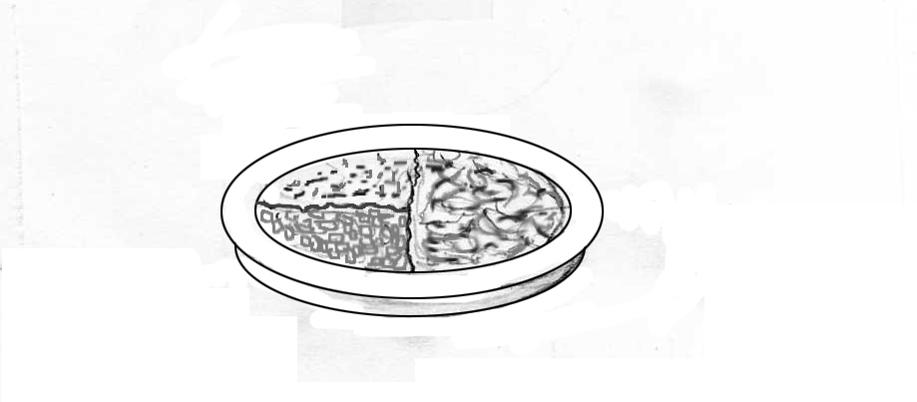
Vegetables
Staple
Legumes and/or meat or fish
Figure 24.1. The plate method for portion size: “Fill half your plate with vegetables, one fourth with legumes and/or meat/fish, and one fourth with cereals or starchy roots.”
© Michele Marcoux 2014
OUP label with Staple, vegetables, legumes and/or meat or fish. Marked up

Healthy cooking
Food preparation in the home, and commercial establishments often includes deep fat frying, over-cooking, and using too much salt, sugar and preservatives. Advise people preparing meals:
- That recommended healthy cooking methods are: boiling, steaming, roasting, grilling, stewing, broiling, sautéing and poaching. Roasting and grilling allows extra fat to drip away. Charred grilled foods increase the risk of cancer;
- To avoid deep fat frying, or blot off excess fat. Reusing (reheating and cooling) fats can change ‘unsaturated fats’ to dangerous ‘trans-fats’ see Section 3.2;
- That salads are healthy, but must be prepared hygienically, and dressings should be low in kilocalories; and
- Not to add salt or sugar to meals and drinks, including tea or coffee.

Shopping
- Advise buying local in-season cheap fruits and vegetables – imported ones are not healthier and are often expensive;
- Explain food labels (where they exist) so people can check:
- fat content and type (in order to avoid foods high in fat especially trans fats); and
- sugar and salt content.
- Advise not to shop when hungry.

When eating out
- Choose healthy foods and small portions;
- Share food with a friend, or take half home;
- Avoid sweetened high-calorie drinks; instead drink low-calorie drinks such as safe water, low fat butter milk, vegetable juice, and coconut water – see Figure 24.2.

<Figure 24.2>
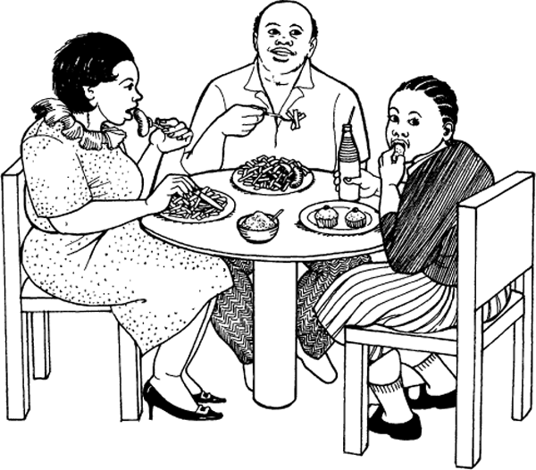
Figure 24.2 [Fig. 22–5] How would you counsel this family?
©Felicity Savage King and Ann Burgess 1992; artist Sara Kiunga Kamau.

Training exercises
Ask each trainee to pretend she or he lives with diabetes, and to make a menu and shopping list for a day’s meals. Discuss how their choices differ from the food they normally eat.

Cook rice, legumes and vegetables, and demonstrate on a plate what proportion of each food a person living with diabetes should eat.

Use a key to the door of a room to demonstrate how insulin is like a key that opens the door of the cell to let glucose in.

Resources
International Diabetes Federation. 2009. Clinical Guidelines Task Force. Global Guideline on Pregnancy and Diabetes. IDF, Brussels. www.idf.org/webdata/docs/Pregnancy_EN_RTP.pdf
International Diabetes Federation. 2012. Clinical Guidelines Task Force. Global Guideline for Type 2 Diabetes. IDF, Brussels. www.idf.org/sites/default/files/IDF-Guideline-for-Type-2-Diabetes.pdf
Websites
International Diabetes Federation. Glycaemic index wheel. www.idf.org/worlddiabetesday/2009-2013/materials/glycaemic-index-wheel
World Obesity www.worldobesity.org
Zimbabwe hand method. http://medweb.bham.ac.uk/easdec/prevention/portionsize.htm
World Health Organization 2013. Diabetes Fact sheet www.who.int/mediacentre/factsheets/fs312/en /

